|  |  |
| --- | --- |
| **Instructor:**   * Mr. Nazeef Ul Haq (Lab) |  |

**Learning Objectives:**

* Understanding of Subqueries.

**Helping Material:**

**1. Create Crystal Report for Employee Data information**  
first create an Employee Data Table in your SQL Database.  
Now, follow the steps for creating a Crystal Report.  
**Step 1**

Go to Visual Studio and create a new project.  
**Step 2**

Go to the Solution Explorer and right-click on your project name and select Add -> New Item.  
  
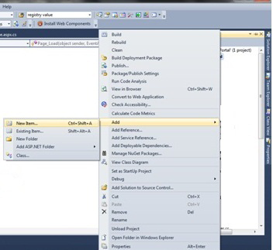

**Step 3**

Add New Item-> Crystal Report.  
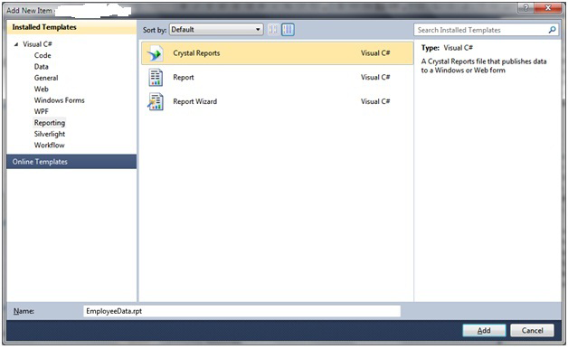  
**Step 4**

Click the Ok Button.  
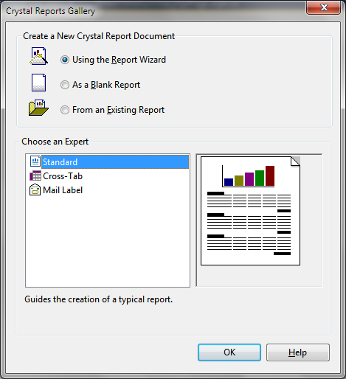

**Step 5**

Choose the data source as in the following:  
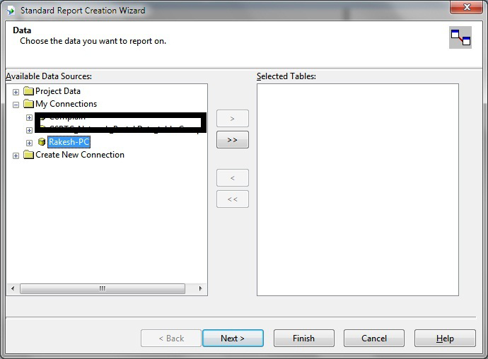  
Click the Next Button.  
**Step 6**

Select the data with OLEDB (ADO) as in the following:  
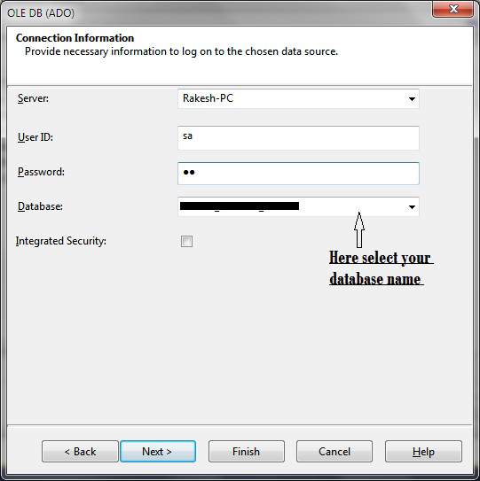  
  
Click the Next button to open a new dialog.  
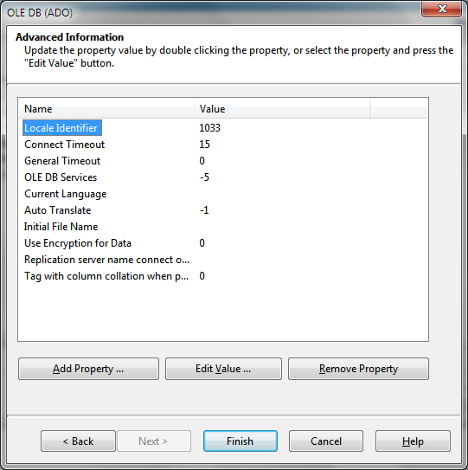  
Click the Finish button and open a new dialog box. In this, select your new view.  
**Step 7**

Select your view Employee view.  
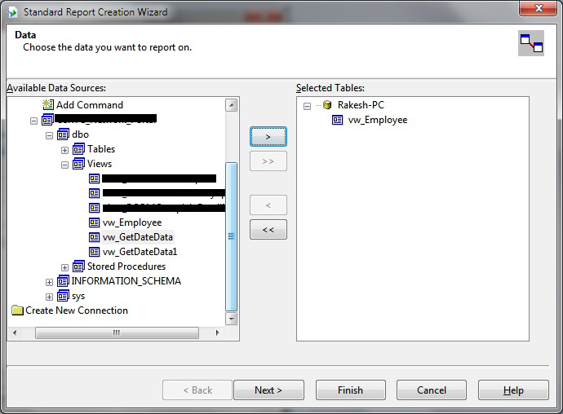

**Step 8**

Select the fields to display in the report area as in the following:  
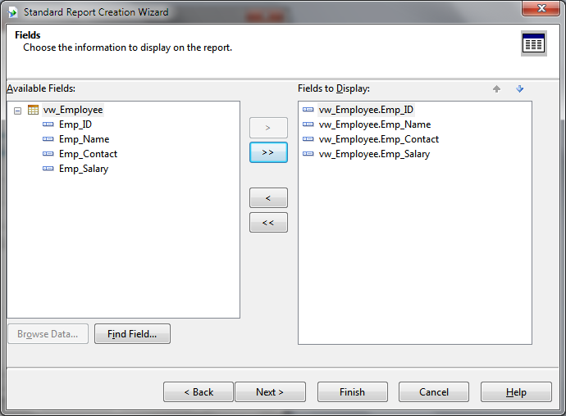  
And click the Finish button.  
**Step 9**

Select the report format as in the following:  
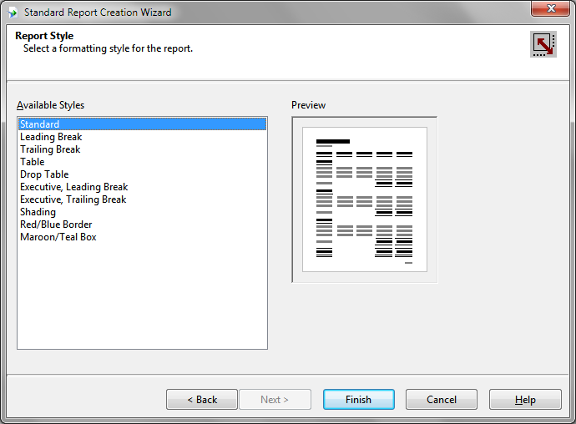

Click the Finish Button after selecting the format of the report.

**Step 10**

Now finally display your report in this format.  
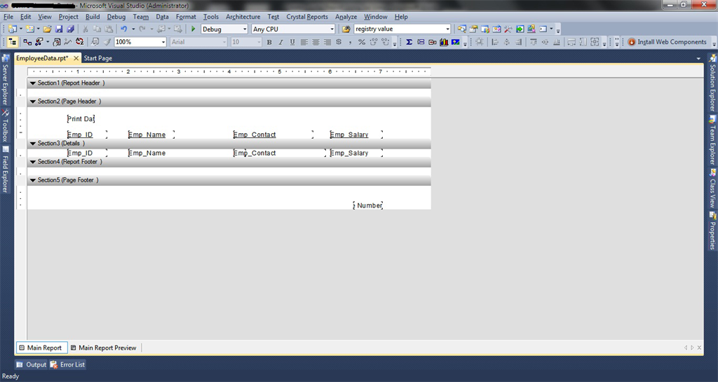  
  
**Step 11**

Next follow the instructions given in the lab.

**Helping Code:**  
private void crystalReportViewer1_Load(object sender, EventArgs e)

{

ShowReport();

}

private void ShowReport()

{

ReportDocument r = new ReportDocument();

string path = Application.StartupPath;

string reportpath = @"CrystalReport1.rpt";

string fpath = Path.Combine(path, reportpath);

r.Load(fpath);

crystalReportViewer1.ReportSource=r;

}

**Helping Link:** [**https://www.youtube.com/watch?v=079OLMGqZwg&t=460s**](https://www.youtube.com/watch?v=079OLMGqZwg&t=460s)

**HackerRank Tasks:**

* <https://www.hackerrank.com/challenges/occupations/problem?isFullScreen=true>
* <https://www.hackerrank.com/challenges/binary-search-tree-1/problem?isFullScreen=true>
* <https://www.hackerrank.com/challenges/weather-observation-station-20/problem?isFullScreen=true>
* <https://www.hackerrank.com/challenges/harry-potter-and-wands/problem?isFullScreen=true>
* <https://www.hackerrank.com/challenges/contest-leaderboard/problem?isFullScreen=true>
* <https://www.hackerrank.com/challenges/sql-projects/problem?isFullScreen=true>